|  |
| --- |
|  |
| Unit 6:Methods of Integration, Logistic Growth & Euler’s Method |
|  |

Our Learning Goals:

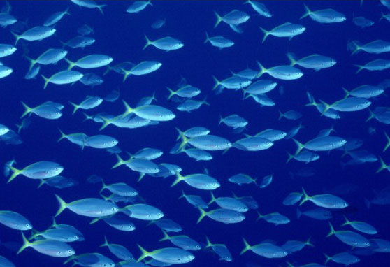

# Sample Problem:

Biologists stocked a lake with 400 fish and estimated the carrying capacity to be 10,000. The number of fish tripled the first year. Assuming that the size of the fish population satisfies the logistic equation, find an expression for the size of the population after $t$ years.

|  |
| --- |
|  |
| Additional Support:  * Check the teacher web page and Canvas page for notes, activities, and assignments. * Search the topic on the web. We recommend using Khan Academy and CollegeBoard Student Resources. * Attend tutorials. |

**We will:**

* Use integration by parts and by partial fractions to solve applicable integrals.
* Analyze and interpret directional fields and differential equations related to logistic growth problems.
* Apply Euler’s Method to estimating differential equation solutions.
* Evaluate improper integrals.
* Determine the length of an arc using integration.

|  |
| --- |
|  |
| Why do we study this?   * Population growth patterns are used to determine community needs and requirements. * Integration allows us to quantify accumulation in a variety of situations. * As long as we can model how something is changing, we can then use integration to determine that change and even predict outcomes such as population for the future. This unit explores different types of integration and ways to estimate solutions when integration is not an option. |
|  |

How we will show what we have learned…

|  |  |
| --- | --- |
| Formative Assessments | Summative Assessments |
| Ongoing formative assessments during lesson and homework activities will help in monitoring learning and providing feedback for students. | * Summative assessments to measure learning at the end of concepts will include teacher-made tests and a district common assessment, which includes multiple choice and free response questions. |